M.D.S.D. COLLEGE, AMBALA CITY
(Affiliated to Kurukshetra University, Kurukshetra)
APPLICATION FORM FOR THE POST OF PRINCIPAL
Website: www.mdsd.ac.in Email: mdsdprincipal@gmail.com
Sr. No. ……………

Attested
photograph
NOTES:
- The last date of receipt of application (only online) is 05.05.2026
- This application form and bio-data should be properly filled in.
- Self Attested copies of all certificates/testimonials should be attached.
(Originals will have to shown at the time of interview).
- Persons in employment should send their applications through their employers.
- Applications received after the due date or found incomplete may not be considered.
_________________________________________________________________________
- Post applied for (Give the full name of the post)……………………………………………………………..
Advt. Date………………………………………………Newspaper
- Name in Full (in block letters)…………………………………………………………………………………………
- Present Postal Address (in block letters)…………………………………………………………………………
…………………………………………………………………………………………………………………………………………
- Mobile No.………………………………………E.Mail ID…………………………………………………………………
- Permanent Home Address……………………………………………………………………………………………
…………………………………………………………………………………………………………………………………………
Pin Code………………………………………………………………………………………………………………………….
- Father’s/Husband’s Name………………………………………………………………………………………………
- A) Nationality of the Candidate………………………………………………………………………………
b) Marital Status……………………………………………………………………………………………………..
8. a) Date of Birth………………………………………
9. Whether belong to any reserved category? (SC/ST/BC-A/BC-B/ESM/PH)
If Yes, specify the category : …………………………………………………………………………………………..
10. If physically disabled, indicate the relevant particulars
Nature of Disability | If applicable , write ‘Yes’ | Percentage of Disability
- Blindness or low vision
- Hearing impairment
- Locomotor disability or cerebral palsy (includes all cases of orthopedic handicaps)

11. If you are employed, your present designation……………………………………………………………….
and name of institution where employed……………………………………………………………………….
12. References:- These should be Professionally competent persons who are well acquainted with some aspects of the applicant’s training accomplishment, capabilities, and the character but must not be in relations. Two references should be listed, and at least one of them should be citizen of India. For applicants having done post-graduate or post-doctoral research, supervisors must be listed.
i) Name………………………………………………………………………………………………………..
Occupation or Position……………………………………………………………………………..
Address……………………………………………………………………………………………………..
ii) Name…………………………………………………………………………………………………………
Occupation or Position……………………………………………………………………………..
Address………………………………………………………………………………………………………
13. Have you ever been prosecuted, kept under detention of bound down, fined, convicted by a Court of law of any offence or debarred/dis-qualified by any University’s Public Service Commission from appearing at its examinations/selection? Is any case pending against you in any court of law at the time of filling up of this application from? If the answer is ‘Yes’ full particulars of the case, detention, fine, conviction, sentence etc. should be given.
14. Educational Qualifications (from Matriculation onwards):
Exam passed | Univ./Board | No. of attempt | Roll No. | Year of Passing | Class/Divn. | Max. Marks | Marks obtained | %age Marks | Subject distinction
Matric

10+2

B.A./B.Sc./B.com

M.A./M.Sc/M.com.
M.Phil

Ph.D.

UGC/CSIR
JRF Exam.
Any other

Indicate specifically whether Ph.D Degree has been awarded Yes/No
15. If you are appointed teacher of a recognized college (Attach copy of Approval letter of the University) …………………………………………………………………….

16. Topic of M.Phil Dissertation……………………………………………………………………………………….
17. a) Topic of research for Ph.D……………………………………………………………………………..
b) Field of specialization…………………………………………………………………………………….
18. Teaching Experience
Chronological list of experience (including current position/employment)

Name of the employer/institution | Designation | Duration of experience |  | Nature of appointment/Work/Duties | Basic pay & Grade
 |  | From | To

19. Total experience (i) Under Graduate classes……………………………………………………………………
(ii) Post Graduate classes…………………………………………………………………………

20. Period required for joining the post if selected………………………………………………………………

21. List below the certificates and testimonials (attested copies) attached:-

(Signature of the candidate)

Account NO. 373001000825 IFSC code ICIC0003730 Amount 1000/- Name of the Bank ICICI BANK, NOVELTY CHOWK, AMBALA CITY

NOTE: ATTACH PROOF OF PAYMENT

Date: Yours faithfully
Place:

(Signature of Applicant)

D/o S/o W/o hereby declare that all the entries made by me in this application form are true and correct to the best of my knowledge and I have attached related proof of documents in form of self attested copies. If anything is found false or incorrect at any stage, my candidature/appointment is liable to be cancelled.
Place:
Date:

(Full Signature of the Candidate)

CERTIFICATE FROM THE EMPLOYER, IFANY

The application of Ms./Mr./Dr. who is at present working as
in Department/Organization is forwarded and recommended for consideration. In case she/he is selected in M.D.S.D. College, Ambala City, she /he will be relieved from her/his present position on notice.

Place:

Date:

Signature of the Head of Institute/ Organization (Seal of the office)

SCORESHEETS
(As supplied from DGHE vide dated 18.04.2023 available on college website)
Category | Maximum Marks | Weightage Claimed | Marks Awarded
I. Academic Record | 20 marks
II. Teaching Experience and Assessment of Administrative Skill | 35 Marks
III. Academic/Research Score | 32.5 Marks
IV. Interview | 12.5 Marks
Total | 100 Marks

- Academic Record: Maximum 20 marks

S.No. | Particulars | Marks | Self-appraisal  Marks | Marks  awarded
1. | Above 55% marks in Master’s degree | 0.5marksforeach  percentage (maximum 5 marks)
2. | Above 55% marks in Graduation | 0.4 marks for each percentage  (maximum 5 marks)
3. | Above 55% marks in 10+2/Prep. | 0.3 marks for each percentage  (maximum 5 marks)
4. | Above 55% marks in Matriculation | 0.2 marks for each percentage (maximum 5 marks)

- Teaching Experience and Assessment of Administrative Skill: Maximum 35 marks
  - Teaching Experience: Maximum 10 marks

S.No. | Particulars | Marks | Self-appraisal  Marks | Marks  awarded
1. | Above 15 years teaching  experience | 1 mark for each year

  - Assessment of Administrative Skill: Maximum 25 marks
    - Experience of Administrative Responsibilities

S.No. | Particulars | Marks | Self-appraisal  Marks | Marks  awarded
1. | Experience as Joint/Deputy/Assistant Director in Directorate of Higher  Education | 1 mark for each year
2. | Experience as Registrar or any other  Administrative post in any University | 1 mark for  Each year
3. | Experience as Head of the Higher Education Institution i.e. Principal,  Officiating Principal/DDO | 1mark for each year

    - Experience of Key responsibilities in colleges

S.No. | Particulars | Marks | Self-appraisal  Marks | Marks  awarded
1. | Staff Representative or V.C. Nominee in Managing  Committee of any College | 1 mark for each year maximum upto 3  Marks
2. | Co-ordinator or Organizing Secretary of International/National/State  Conference/Event | 1 mark for each year maximum upto 3 marks
3. | Bursar | 1 mark for each year maximum upto 3  Marks
4. | NSS Programme Officer | 1 mark for each year Maximum upto 3 marks
5. | YRC Counsellor | 1 mark for each year maximum upto 3  Marks
6. | Hostel Warden | 1 mark for each year Maximum upto 3 marks
7. | Member of any Statutory Body of University | 1 mark for each year Maximum upto 2  marks
8 | Experience as Associate NCC Officer in HEI (s) | 1 mark for each year Maximum upto 3 marks

    - Experience of Committees in College

S.No. | Particulars | Marks | Self-appraisal  Marks | Marks  awarded
1. | Co-ordinator IQAC | 1 mark for each academic  Year maximum upto 2 marks
2. | Editor in Chief, College  Magazine | 1 mark for each academic  Year maximum upto 2 marks
3. | Member, College  Advisory Council | 1mark for each academic  Year maximum upto 2 marks
4. | Convener, University  Work Committee | 1 mark for each academic  Year maximum upto 2 marks
5. | Convener, Cultural  Affairs Committee | 1 mark for each academic  Year maximum upto 2marks
6. | Convener, Purchase/Procurement  Committee | 1 mark for each academic year maximum upto 2marks
7. | Convener,  Building/Works Committee | 1 mark for each academic year maximum upto 2 marks
8. | Convener, Sports  Committee | 1 mark for each academic  Year maximum upto 2 marks
9. | Convener, Discipline  Committee | 1 mark for each academic  Year maximum upto 2 marks
10. | Convener, Internal  (Complaint)Committee | 1 mark for each academic  Year maximum upto 2 marks
11. | Convener, Road Safety  Club | 1 mark for each academic  Year maximum upto 2 marks
12. | Convener, Red Ribbon  Club | 1 mark for each academic  Year maximum upto 2 marks
13. | Convener, Eco Club | 1 mark for each academic  Year maximum upto 2 marks
14. | In-charge, Placement  Cell | 1 mark for each academic  Year maximum upto 2 marks
15. | Incharge, Women Cell | 1 mark for each academic  Year maximum upto 2 marks
16. | In-charge, Time-table  Committee | 1 mark for each academic  Year maximum upto 2 marks
17. | In-charge, SC/BC  Committee | 1 mark for each academic  Year maximum upto 2 marks

III. Academic/Research Score: Maximum32.5marks

S.No. | Particulars | Marks | Self-appraisal  Marks | Marks  awarded
1. | Research Score above 110 as per The criteria given in Appendix II,  Table2 | 0.3 mark for each 1 Research Score  above110
**Attach copies as proof of documents for your calculated API score according to

Annexure attached with this form– Table 2, Appendix II (as supplied by DGHE)

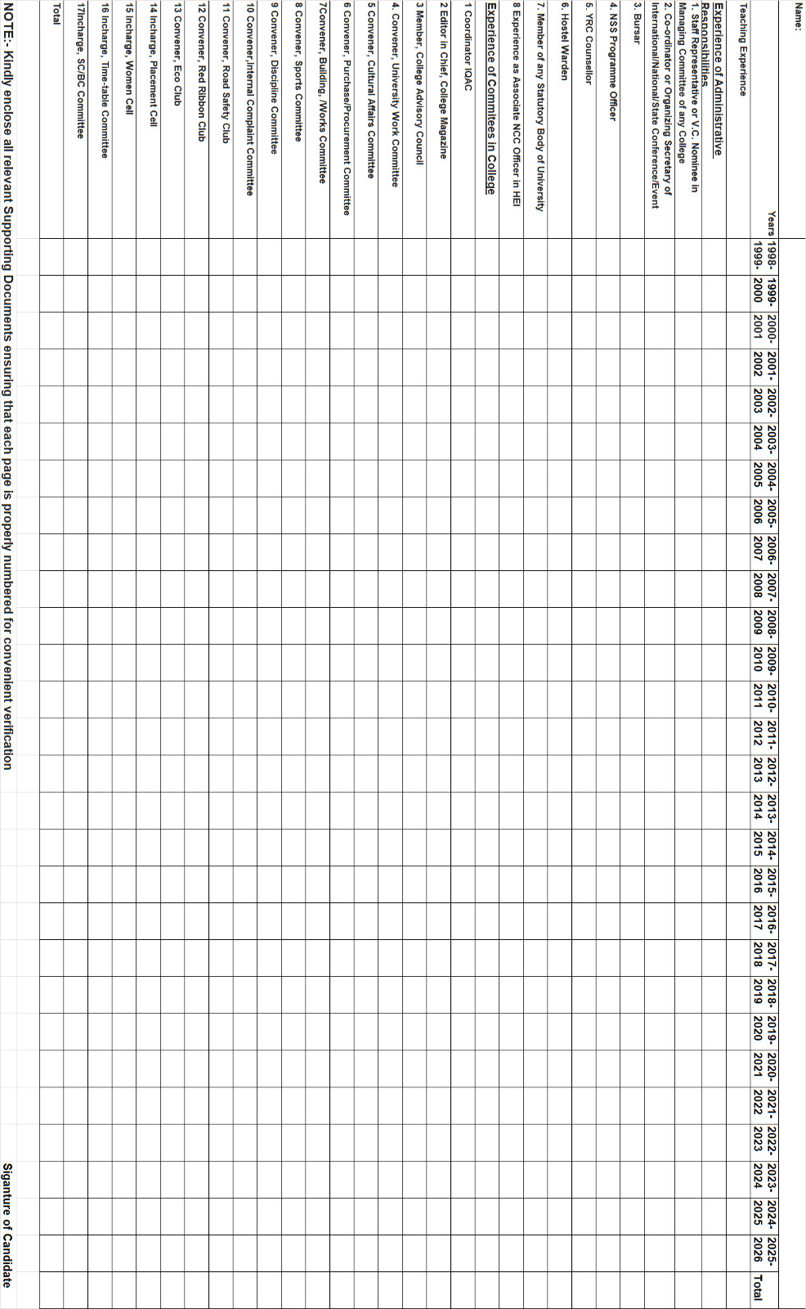

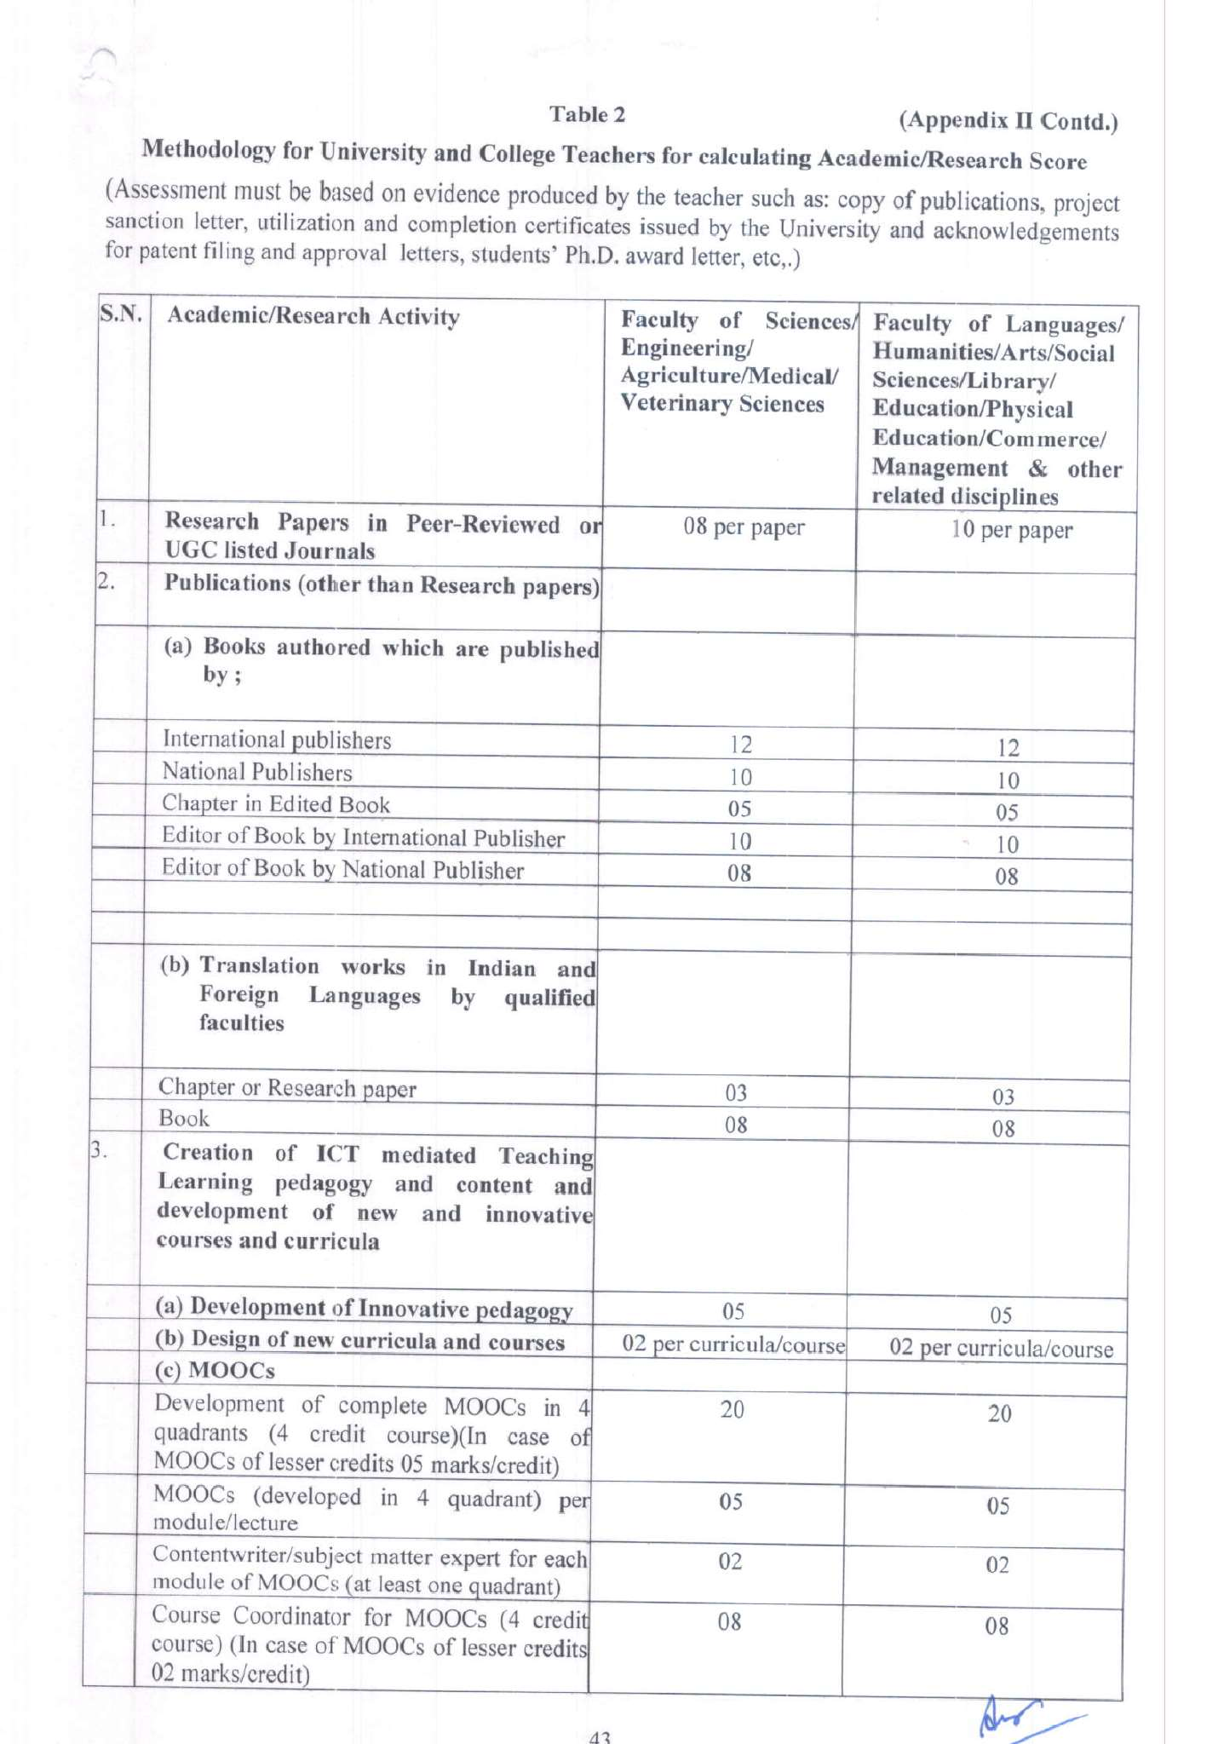
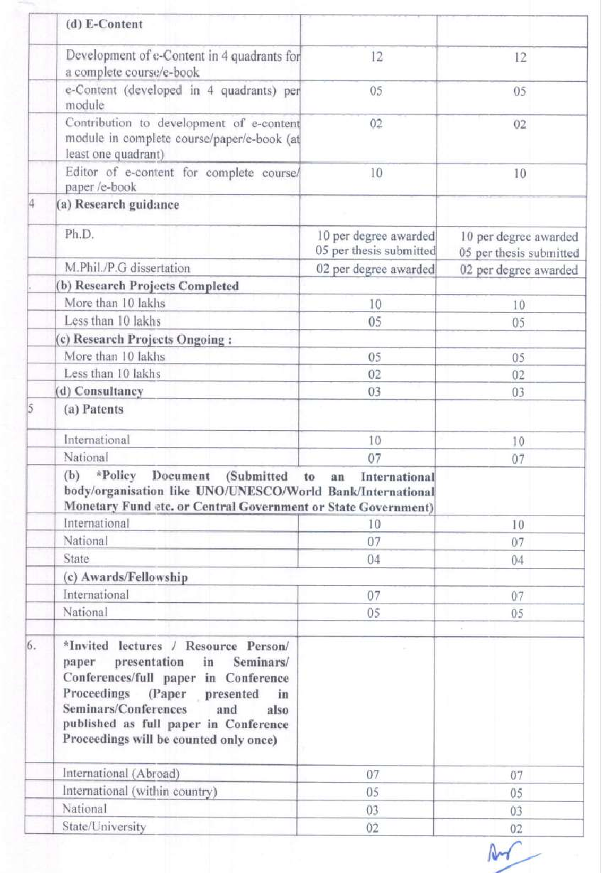
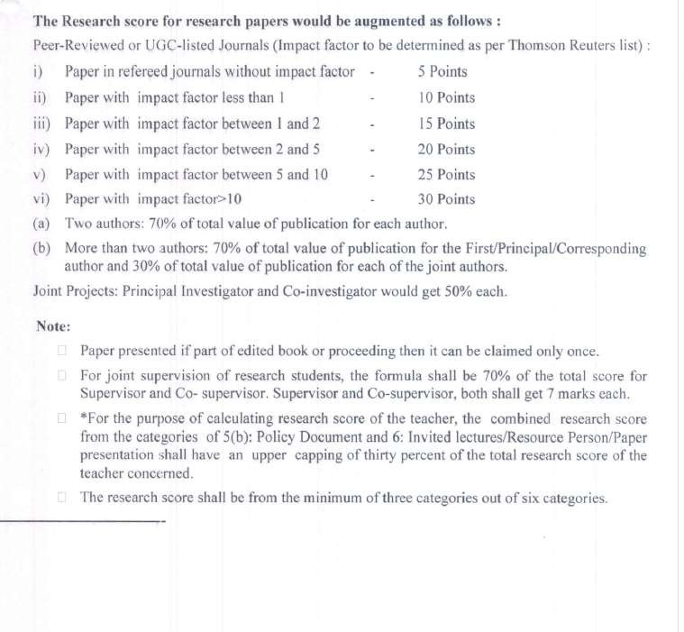
NOTE : KINDLY ENCLOSE ALL RELEVANT SUPPORTING DOCUMENTS ENSURING THAT EACH PAGE IS PROPERLY NUMBERED FOR CONVENIENT VERIFICATION.

