M.D.S.D Girls College , Ambala City

Policy for Incubation Centre
The incubation centre at MDSD Girls College Ambala aims at the blend of thinking, innovation and empowerment. The centre was established as a skill development vocational centre with optimum utilization of high grade infrastructure having 26 sewing machines, 19 dummies, 3 cutting tables, umbrella machine, interlocking machines and fashion maker machines.
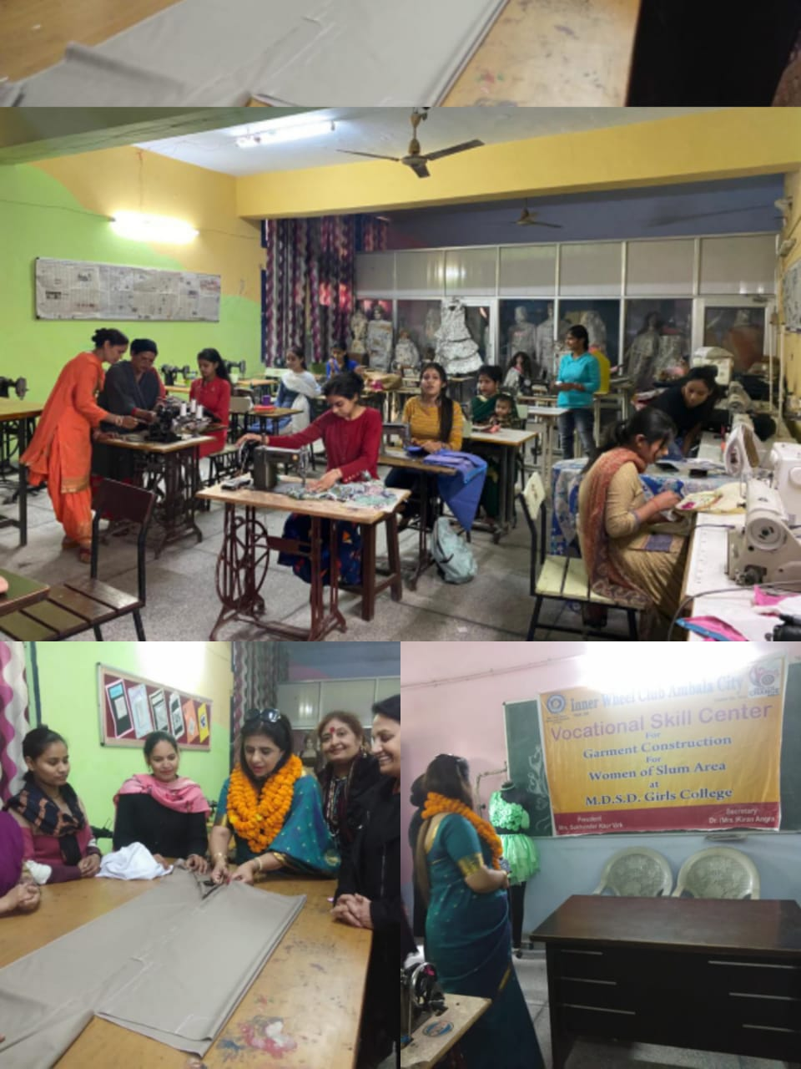
In the past five years 100 women were trained in garment construction and now these women run their own successful boutiques. Ambala city is a well known whole sale market of North India and the incubation centre acted as a link between these skilled women and cloth market merchants to facilitate their placements and help them earn their livelihood. Moreover the poor women trainees were given sewing machines to assist them in starting their own business.

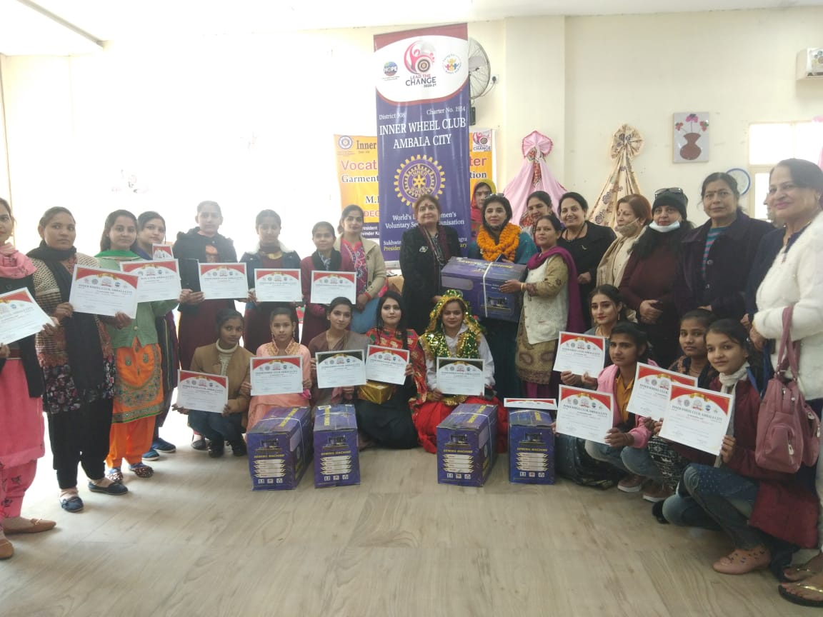
The first project undertaken in this centre was under the theme ‘BEST OUT OF WASTE’. In the incubation centre, used bed sheets auctioned by the Railway Department are collected through a contractor, and, further after tailoring and dyeing these bed sheets were re-designed and then put for sale. In this way we have not only provided self-employment to women but also extended our support to the bigger community by fostering socio-economic development. This INCUBATION CENTRE is opened for all and provides facilities to the common women to show their abilities in the field of creation and do something innovative which can strengthen sustainable development.

